FEMA Flood Insurance Study – 2014 => link
(Note Table 7 - page 36 listing peak discharges somewhat different than Goodkind & O’Dea)

Sparkill Creek Flooding Summary
The Town of Orangetown is presently subject to flooding from Sparkill Creek in the eastern portion of town and from Muddy Creek in the west. These flooding problems are a result of inadequate drainage facilities and the increased urbanization of the area. The three areas of Orangetown along Sparkill Creek that usually suffer the most severe problems are: the area west of Greenbush Road in the vicinity of Spruce and Hickery Streets, along State Route 303 in the Orangeburg Road area, and the area in the vicinity of State Route 340 and Valentine Avenue.
In the Spruce and Hickery Street area, major obstructions lie in the undersized culvert at Spruce Street and in a small private culvert across an access road, north of Spruce Street. Along State Route 303 in the Orangeburg area, the channel is narrow and encroached upon by various structures. Additional problems have been created by the filling of portions of the areas north of State Route 303 and between Orangeburg Road and Conrail where ponding has occurred during major storms. The fire house pumping station, a church and various residences in the vicinity of Valentine Avenue, William Street, and State Route 340 experience frequent flooding due to an undersized and deteriorating culvert under Valentine Avenue, along with a narrow winding channel upstream of Valentine Avenue. In addition to being undersized, the Valentine Avenue culvert experiences frequent debris jams during high flows, which further aggravates flooding.
And in Piermont:
Piermont is presently subject to flooding from Sparkill Creek and the Hudson River. Tidal marshlands adjacent to the Hudson River are subject to flooding from both Sparkill Creek and the Hudson River.
The low drawbridge on Bridge Street has frequently been overtopped by Sparkill Creek stormwaters. Paradise Avenue, downstream of the Bridge Street Bridge, is also subject to flooding from Sparkill Creek. The parking areas of the Continental Can Company on the waterfront are often flooded by the Hudson River.
Comment- this information looks outdated as the Valentine Ave bridge was replaced some years ago as well as the Spruce St. bridge. Many other references are clearly 10 to 20 years old. Also I would not characterize the channel upstream of the Valentine bridge as narrow though it has been encroached by some filling and the stream meanders in the flood plain at this point.

Examples of Flooding Events on the Sparkill Creek
(For an extensive list of pre-Irene flooding events in Westchester county about 10 miles east see this link at Table 5.4.2-2 on ward)

July 1994 – Reported in Goodkind & O’Dea Flood Analysis Report – 1999
Rainfall – Valentine Ave. Stream Gauge – 5.6”/24hr.- about 25 year storm, based on 1961 atlas
Flooding – Extensive - Storm of record as of 1999

Sep 1999 – Tropical Storm Floyd – probably now the storm of record
Rainfall – Rockland County – totals of 13” or more
Flooding – Extensive – destroyed bridges; flooding at all of the problem areas listed. Water over Spruce St, Rt 303 in several places, Rt 340 at Rt 303, Oak Tree Road, Valentine Ave etc)

27 - 28 Aug 2011 – Tropical Storm Irene
Rainfall - Rockland County – estimated 6 to 6.5”- about 25 year storm or more
Flooding – extensive – including Rt 303, both crossings of Oak Tree Rd, Sparkill Firehouse.

Documented Irene Sites

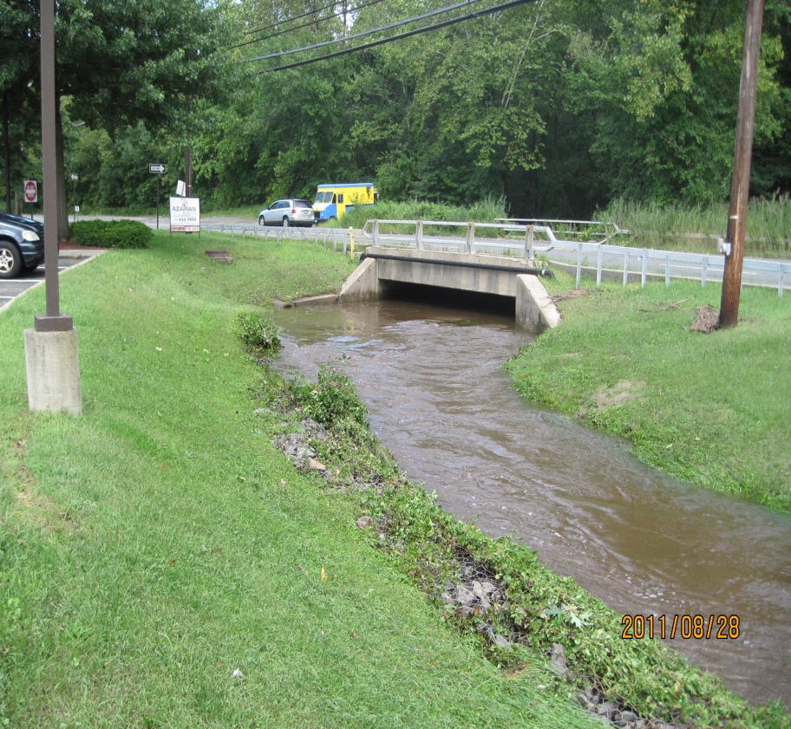
Rt 303 at Mountainview - Flooding subsided by the time of this photo (28 Aug 2011 – 14:05). See line of debris approximately road level probably indicating high water level.

During severe flooding the highway is flooded from here south at low points.

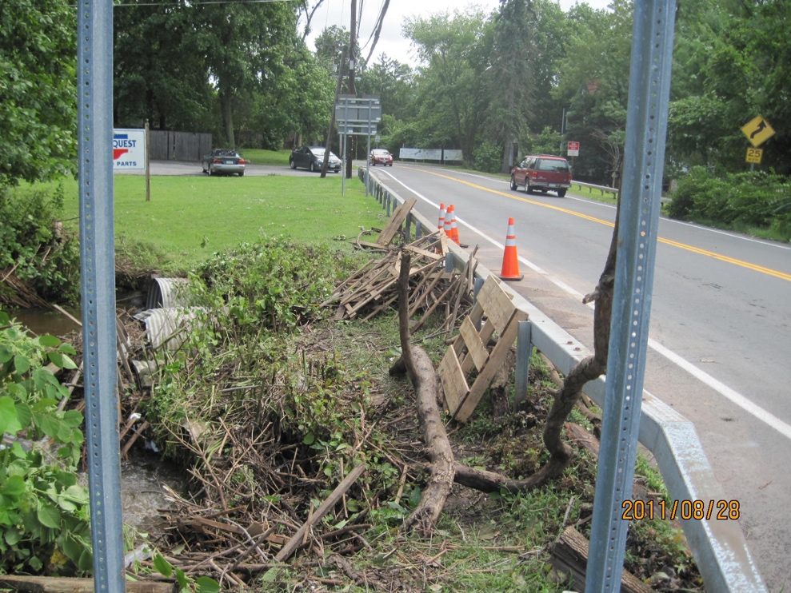
Rt 340 at Rt 303
Extensive debris collected at this culvert by flood water (and undoubtedly piled by road crews). Evidence of debris somewhat above road level. Water had subsided by the time of this photo (27 Aug2011 14:02).
Impervious area, poor culvert design, debris and narrow downstream channel make this spot a common problem even though not in lower reach.
.
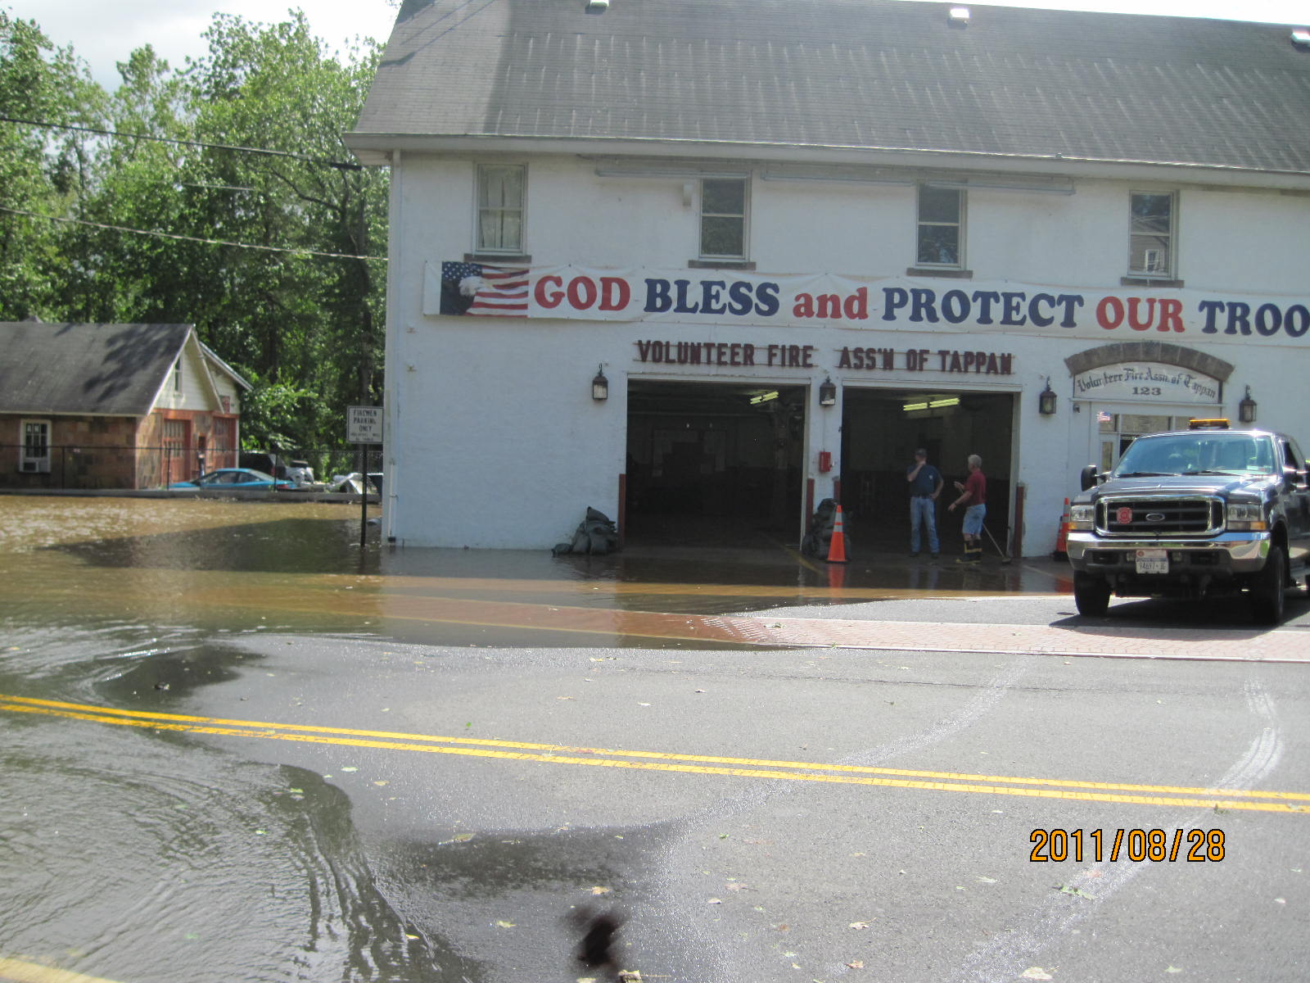
Tappan Firehouse (28Aug2011 14:29). Flood water reaches just beyond first floor entrance level. Creek crosses Washington Ave to the left where water is significantly above roadway.
Tappan Library and Van Wardt area is just downstream of this location.

Tappan Library
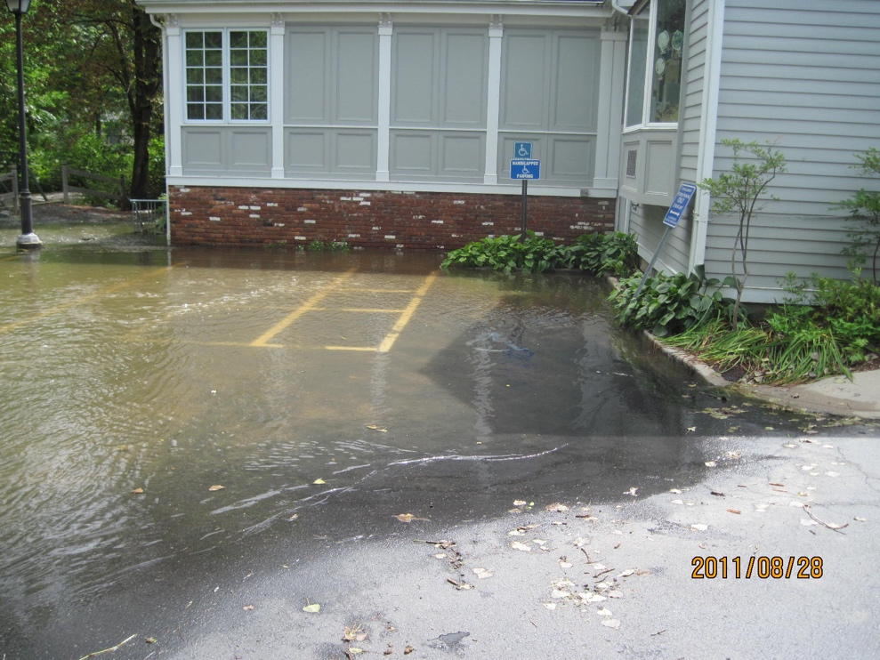
Waters from creek at left just reach the bottom floor doorway (28Aug2011 14:16)

Van Wardt /OakTree Rd is just downstream of this location.

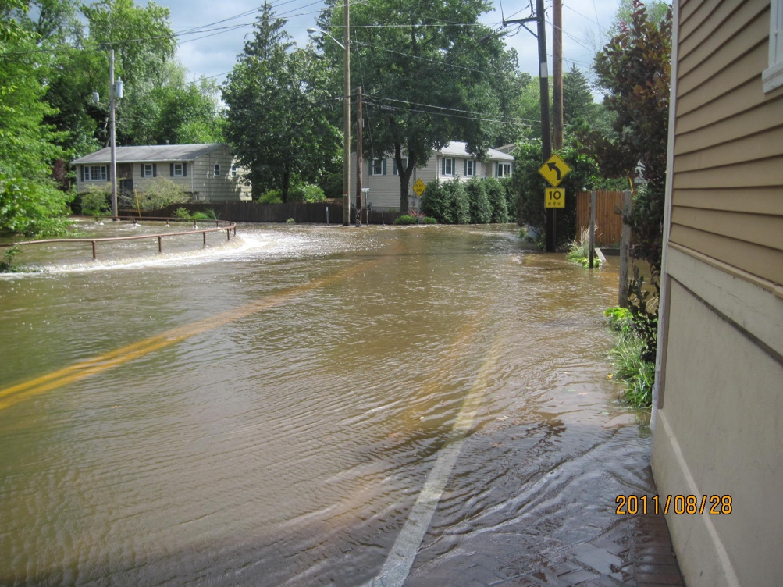
Van Wardt (28Aug2011 14:19) Photo is looking east on Oak Tree Rd; Van Wardt is small street to the right. Flood water spills over a railed wall at the sidewalk and extends a block down Van Wardt and into several houses. Creek makes a left bend at Washington then crosses under the road bohond the house at left. A replacement bridge was installed ~2015 and should lessen this problem. Dry conditions have prevailed since the new bridge.

Crossing at Rt 303 Tappan; Livingston, Northvale
Reported extensive road flooding at this crossing at the state line – no photos

Oak Tree Road Crossing at Palisades boundary
Observed extensive roadway flooding at this crossing shortly after visiting Tappan. No photos
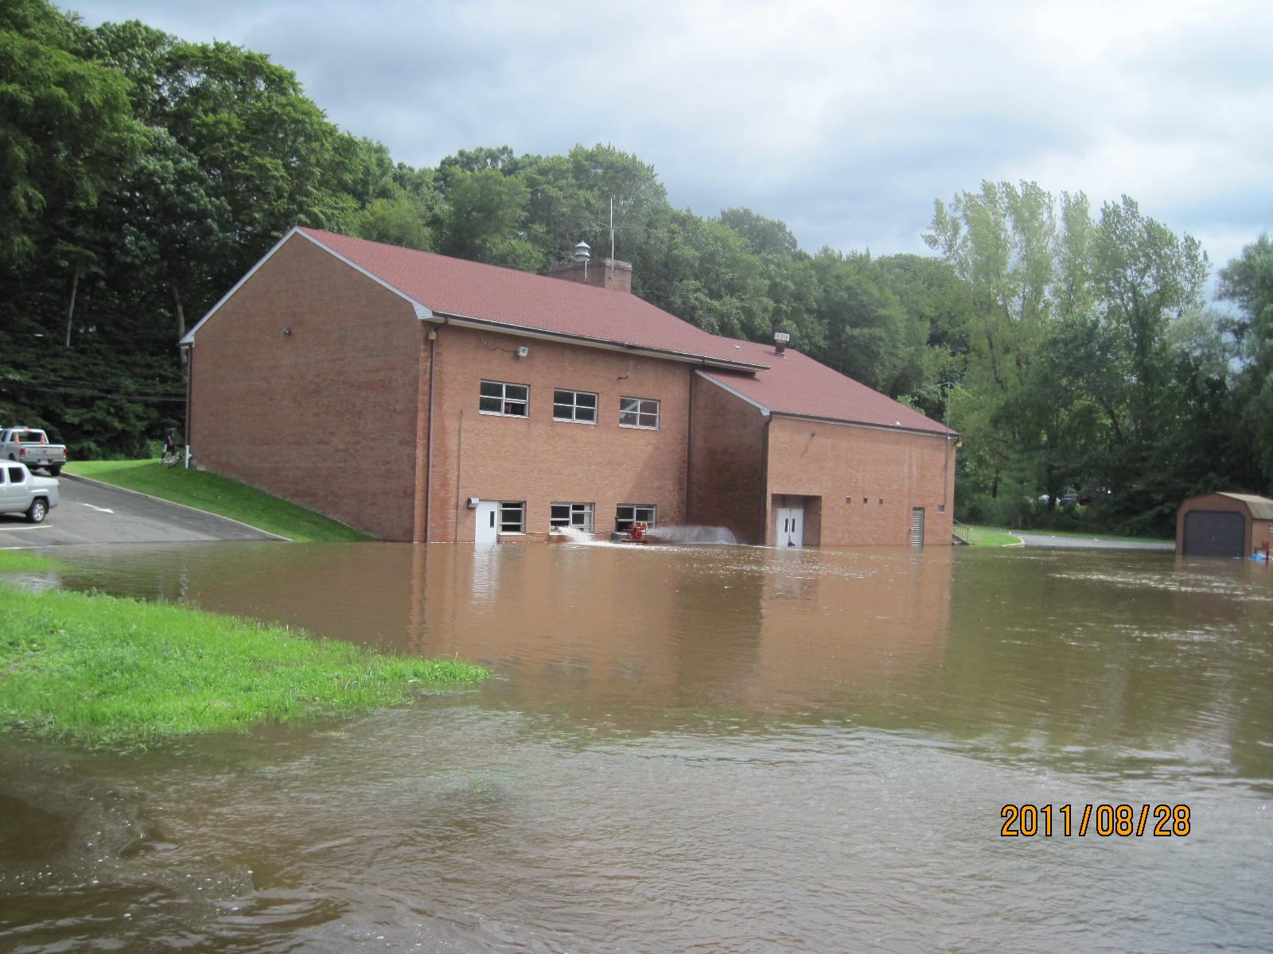
Sparkill Firehouse (28Aug2011 14:46)

Creek beyond photo at right floods building to a depth of about 12-18”. Firemen have developed a system of pumps to remove flood water since it first flooded soon after construction ~1960.
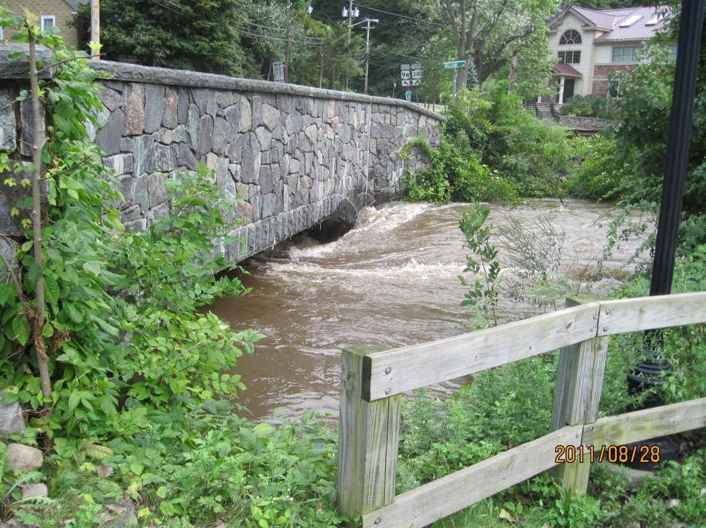
Water at the Williams Street Bridge just downstream is just at the culvert ceiling.

Just downstream of this bridge is the Valentine Bridge (27Aug2011 14:43) that replaced an old bridge destroyed by TS Floyd in 1999, Water has slightly more room under this bridge.

This map has the above locations and more.

